*5p) Define the following: Task, Pipelining, Shared Memory, Communications, Synchronization. (in your own words)*

**Task:** Task is a set of instruction that the processor must run to accomplish the program that was assigned by programmer. So far, we have covered the logical operations task, which is a basic arithmetic. Today, processor is getting better then after before, and CPU can perform multiple task at once using a parallel programing skill.

**Pipeline**: The pipeline will break down the assigned tasks into the smaller task. By doing so, computer can group the task base on the same instruction set to save the performance(time).

**Shared Memory:** Memory is being shared regardless where memory is located. This is because the memory is steered only in one physical memory. One advantage of shared memory is that the all memory would share the same “address bus” and computer architecture, every logical operation would directly related to another.

**Communications:** to perform a parallel task, the communication is inevitable. The multi-task is current trends and sharing the data within the memory is necessary. One way to communicate (exchanging data) is to use a address bus. One restriction for using a address bus is that the “Shared memory” is necessary.

**Synchronization:** Synchronization is like the control unit in CPU where it coordinate the all task at the same period. Synchronization often cooperate with the “communication” to accomplish the task. Synchronization checks whether the all tasks was accomplished before moving to another task.

(*8p) Classify parallel computers based on Flynn's taxonomy. Briefly describe every one of them.*

Flynn’s taxonomy have a 4 classification in parallel computing. These ar1)“Single Instruction stream Single Data Stream(SISD) 2) Single Instruction stream Multiple Data Streak (SIMD), 3) Multiple Instruction Stream Single Data Stream(MISD) ,4) Multiple Instruction Stream Multiple Data Stream(MIMD).

To explain the difference among all classification, the SISD was used in the oldest computer since it only can have single instruction; only one instruction can be performed by CPU at one; and Single Data ; only one data can be used in one clock cycle. This is very inefficient to deal with data, and SIMD was invented.

Unlike SISD, SIMD can handle the multiple data at one clock cycle. Each processer can operate the different data to solve a institution. This allow the computer to use a Arrays and vector. And this type of parallel programming is used in most of the modern computer.

Interesting enough, there is a compute that could handle the multiple instruction ,but single data. It is MISD. MISD can only have one address bus between the Process unit, but having a multiple process unit. This allow that the individual processing unit can operate their task as a independent, but the data is being fed into one data pool.

Last, the most advantaged one is called MIMD. This allow computer to perform a multiple instruction, and multiple data pool into one clock cycle. This parallel computing is used in a supercomputers, like server computer. Each Processing unit is independent from another, as well as the data.

*(7p) What are the Parallel Programming Models?*

Parallel programming model is a abstraction of computer architecture, in which tells the essential competent to perform a algorithms and arithmetic of set instruction.

(*12p) List and briefly describe the types of Parallel Computer Memory Architectures. What type is used by OpenMP and why?*

Parallel Computer Memory has two form. One is Uniform Memory Access(UMA), and the other one is Non-Uniform Memory Access(NUMA). The UMA is commonly called as the Symmetric multiprocessor machines because all CPU shares the common(one) memory when performing the parallel computing. Using the identical memory will have equal access and access time to memory. Non-Uniform memory Access would have several memories, connected with Bus. This will allows to CPU to be a independent from another, and it often made by physically linking several SMPs.

To conclude whether the OpenMP is UMA or NUMA, The OpenMP is Uniform Memory Access. The OpenMP is a standard API to support the shared memory multiprocessing programming, and OpenMP must shares the common memory access. Since NUMA has multiple memories connected using bus, it would be inefficient to use NUMA architecture. Thus OpenMP is using UMA.

*- (10p) Compare Shared Memory Model with Threads Model? (in your own words and show pictures)*

In Shred Memory model with threads, the single threads could have a multiple weights. This allows computer to do a serial work, and perform a number of tasks using threads. This eventually make you to run program to schedule and operating system concurrently.

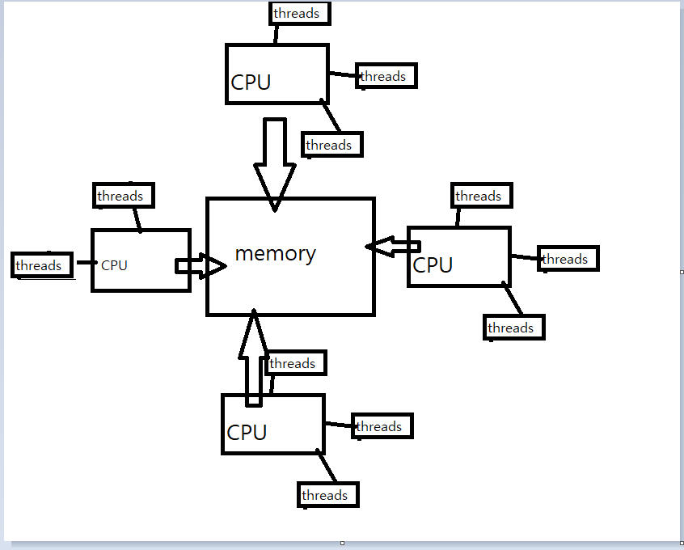

*- (5p) What is Parallel Programming? (in your own words)*

Parallel programming to me is a computer architecture that allow you to perform the multiple tasks concurrently. Instead computer similar task one by one, parallel programming would groups the set of instruction, and schedule appropriate to performs its task faster.

*(5p) What is system on chip (SoC)? Does Raspberry PI use system on SoC?*

SoC is a integrated chips that squeeze the CPU, Ram and GPU into one chip. By doing so, it saves the enormous amounts of space, and allow you to perform as computer. The Raspberry Pi does use SoC that contains gARM1176JZF-S single core CPU, 512 SDRAM.

*(5p) Explain what the advantages are of having a System on a Chip rather than separate CPU, GPU and RAM components.*

Since every component of computer is integrated in SoC, it requires a smaller footprint and space compare to other. Have one single chips increases the reliability since everything is connected to one. And have little power requirement.